AC Managed Equity Portfolio
March 2022 Quarterly Review

Portfolio Performance

The AC Managed Equity Portfolio returned -0.11% compared to the benchmark S&P/ASX 200 (TR) return of 2.24% giving a relative performance of -2.35% for the period.

Performance to 31 March 2022
Return % | One Month | Three Month | Six Month | One Year | Three Year | Since  Inception (29/10/2013)
Portfolio | 3.35 | -0.11 | 0.97 | 1.70 | 13.71 | 11.92
Benchmark | 6.89 | 2.24 | 4.38 | 14.97 | 10.58 | 8.29
Relative Performance | -3.54 | -2.35 | -3.41 | -13.27 | 3.13 | 3.63
The table above sets out the investment performance returns (AFTER investment management fees, but BEFORE administration fees, performance based fees and taxes) for the Portfolio. The performance returns have been calculated on a daily basis taking into account brokerage costs, and are accumulated for the period shown. Returns are shown as annualised if the period is over 1 year, or as total returns otherwise.

Quarterly Review
The Ukraine war dominated the latter part of the quarter, although markets largely took it in its stride, continuing to ignore the economic effects which will surely ensue – namely further supply chain disruptions, shortages of key inputs, demand destruction and inflation. The portfolio unsurprisingly slightly underperformed during the quarter, as we sat defensively, holding 20% cash, several gold positions, and mostly special situations that will benefit from the world chaos. Stocks like the banks, which do quite well as interest rates rise, Elders (reflecting favourable agricultural conditions), AGL, which has been absent from the portfolio for at least a decade, as well as continuing with gold stocks.

Top 5 stocks by weight as at 31 March 2022
Company Name | Sector
NORTHERN STAR ORDINARY | Materials
ELDERS LIMITED ORDINARY | Consumer Staples
ETFS METALS. ETFS GOLD | Financials
COMMONWEALTH BANK. ORDINARY | Financials
NATIONAL AUST. BANK ORDINARY | Financials

Market Outlook
We are about to enter my definition of a bear market this quarter, which is the period from the first rise in interest rates to the final rise of the cycle. This is a more practical definition than the conventional ex post definition of a fall in equity prices.
Bear markets are usually, but not always, associated with sustained periods of largely falling share prices. At best they are associated with very muted positive returns, so the opportunity cost of being wrongly cashed up, as I was in 2021, is not as great.
There is no longer any doubt in my mind that inflation has returned to the sorts of levels last seen in the seventies, and with the energy market in flux from the Russian sanctions, its likely to stay endemic.
In addition, the global expansion of money supply seen over the past 14 years is about to reverse. It has been breathtaking in scale. The big 4 (USA, EU, Jap, China) grew their balance sheets from $US$5 trillion to $US$20 trillion in the decade to 2019 following the 2008 crisis. They’ve added another US$10 trillion in the first two years of covid. There is a high correlation between balance sheet expansion and asset price inflation. So not surprisingly, we’ve witnessed explosions in property prices and equity valuations that has no equal in the past. A whole generation of investors have barely known a correction since 2008 (even the pandemic induced correction in 2020 was just a blip).
We are poised to experience an unwind, plus rising interest rates and bond yields. Markets are pricing in two 50 basis point rises in the USA this quarter, and further rises the next. I predict we will see the first interest rate rise in Australia of the new cycle this quarter, with more to come.
As bridge players will know, there are several “rules” that help play, one of which is the rule of 20. In bridge the rule of 20 is a tool to help decide whether to make an opening bid.
There is also a rule of 20 in stockmarkets. It basically says that a fair value for the market P/E is 20 minus the rate of inflation. So if inflation is around 2%, a P/E of 18 can be justified. If its 8%, then the fair P/E is only 12, which implies a 33% fall in share prices without the earnings (“E”) part declining. If the earnings part is declining due to deteriorating economic conditions, then falls can be much greater. Likewise the higher the market P/E starts from, the greater the falls. We’ve got accustomed to seeing stocks trading on 20-50 times earnings. That is going to end.
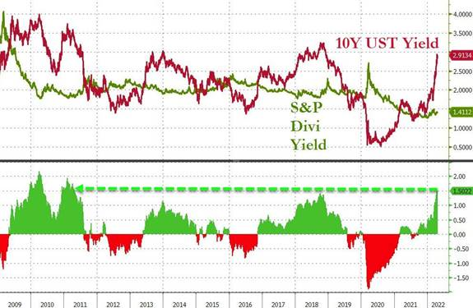
The Chart shows rising bond yields, so equity valuations are under pressure. The recent disconnect will end shortly.
That’s why the bear market of 1973/4 was so savage. That’s why this coming bear market threatens to be very difficult too.
So what is my strategy? Well, the trick is to survive for the coming year so that when the market approaches a bottom, we all have plenty of cash resources to enjoy picking up bargains. Bear markets invariably overshoot, leading to the other extreme of some ridiculously low valuations. As a consequence, the portfolio will be taking profits on its bank positions and moving to 40-60% average liquidity shortly, and sitting out the rest of the year except for special situations and hedges. I do not advocate clients withdrawing from the portfolio in the meantime, as the bottom, when it comes, is typically followed by 50%+ gains within the first 3 months. At that time the media will be full of doom and gloom and warning investors off. That’s the exciting moment I am preparing for.

John Aldersley
April 2022

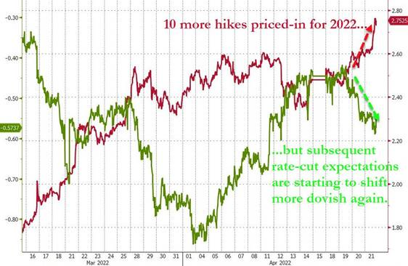

IMPORTANT INFORMATION

Prepared by HUB24 Custodial Services Ltd (ABN 94 073 633 664, AFS licence No. 239 122) ("the Operator” of HUB24 Invest (the Service)) and (("the Promoter” of HUB24 Super (the Fund))". The information contained in this document is not intended to be a definitive statement on the subject matter nor an endorsement that this Portfolio is appropriate for you and should not be relied upon in making a decision to invest in this Service or Fund.

Financial commentary contained within this report is provided by Aldersley Capital Pty Ltd (ABN 14 002 972 901) a corporate authorised representative (No. 420193) of Andika Pty Ltd (ABN 41 117 403 326 and AFSL 297069), who is the Portfolio Manager of this Portfolio.

The information in this report is general information only and does not take into account your individual objectives, financial situation, needs or circumstances. No representations or warranties express or implied, are made as to the accuracy or completeness of the information, opinions and conclusions contained in this report. In preparing this report, HUB24 has relied upon and assumed, without independent verification, the accuracy and completeness of all information available to HUB24. To the maximum extent permitted by law, neither HUB24 or its directors, employees or agents accept any liability for any loss arising in relation to this report.

The suitability of the Service or Fund to your needs and the suitability of a particular Investment Choice depends on your individual circumstances and objectives and should be discussed with your Adviser. Potential investors must read the FSG and IDPS Guide and/or Super PDS along with any accompanying materials.

Investment in securities and other financial products involves risk. An investment in a financial product may have the potential for capital growth and income, but may also carry the risk that the total return on the investment may be less than the amount contributed directly by the investor.

Past performance of financial products is not a reliable indicator of future performance. HUB24 and the Trustee do not assure or guarantee the performance of any financial products offered. Information, opinions, historical performance, calculations or assessments of performance of financial products or markets rely on assumptions about tax, reinvestment, market performance, liquidity and other factors that will be important and may fluctuate over time.

HUB24, its associates and their respective directors and other staff each declare that they may, from time to time, hold interests in Securities that are contained in this Service or Fund.

